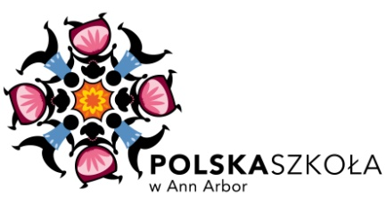 | poledu@yahoo.com  www.PolskaSzkola.weebly.com  215 Alexander Music Building  Eastern Michigan University  Ypsilanti, MI, 48197
Questionnaire
Polska Szkoła w Ann Arbor – Polish Language Center of Ann Arbor

Personal Information
1. Child’s Full Name: _____________________________________________________________

2. Date of Birth:_________________________________________________________________

3. Parents’ Names / Legal Guardian’s Name:
______________________________________________________________________________

4. Telephone & E-mail Contact Information:
______________________________________________________________________________

5. Persons Authorized to Pick up Child:
______________________________________________________________________________
______________________________________________________________________________

6. Health Problems:
______________________________________________________________________________

7. Allergies / Dietary Restrictions:
______________________________________________________________________________

8. School or Daycare the Child Attends?
______________________________________________________________________________

9. Any holidays, festivities from which you would prefer your child to be exempt? _______________________________________________________________________
Abilities / Behavior / Habits
9. Linguistic Level:
comprehension speaking
beginner / advanced beginner / advanced
English ___ ___ ___ ___
Polish ___ ___ ___ ___
Other: __________________ ___ ___ ___ ___

10. What are your child’s favorite stories/books/movies/songs (in any language)?
______________________________________________________________________________
____________________________________________________________________________________________________________________________________________________________

11. What are your child’s favorite activities (music, art, dance, games, toys, etc.)?
______________________________________________________________________________
______________________________________________________________________________
______________________________________________________________________________

12. What are your child’s strengths?
______________________________________________________________________________
______________________________________________________________________________

13. In what situations does your child have difficulties?
______________________________________________________________________________
______________________________________________________________________________

14. Does your child have any fears?
______________________________________________________________________________
______________________________________________________________________________
15. How do you set limits for your child?
______________________________________________________________________________
______________________________________________________________________________

16. Any requests or wishes you may have:
______________________________________________________________________________
______________________________________________________________________________
______________________________________________________________________________
______________________________________________________________________________
______________________________________________________________________________
______________________________________________________________________________

Helping out with the School:
17. Would anyone in your family be able to help with the Polish School In Ann Arbor? Y__ N__
*with the children: i.e. teaching, playing a musical instrument, physical education, art, etc.
______________________________________________________________________________
______________________________________________________________________________
*with the school’s administration: i.e. legal issues, accounting, advertising, pedagogy, lesson preparation, clearing, etc.
______________________________________________________________________________
______________________________________________________________________________

Signature of Parent: _____________________________________________________________

